Elevator System Overview

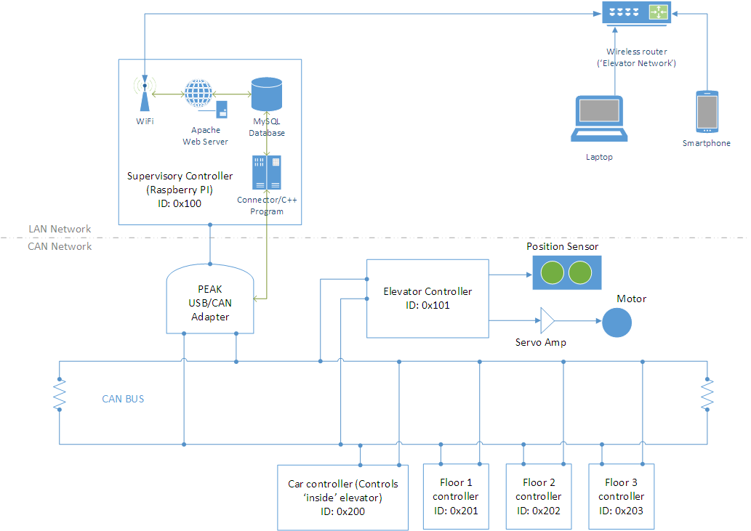

**Supervisory Controller (CAN ID: 0x100)**

* Raspberry PI based
* Bridges LAN and CAN network via PEAK USB/CAN adapter
* Receives its commands (floor requests) from Floor 1, 2 & 3 controllers, Car controller and Web server
* Sends commands to Elevator controller
* Implements a state machine

**Elevator Controller (CAN ID 0x101)**

* Accepts commands only from the Supervisory Controller (ID of message must be 0x100)
* Controls Elevator Car position via servo amp
* Reports Elevator car floor state (position) on CAN network based on inputs from the position sensor

**Car Controller (CAN ID 0x200)**

* Sends floor call request (and possibly door state) on CAN network to the Supervisory Controller
* Receives floor state on CAN network

**Floor Controllers (CAN ID 0x201, 0x202 and 0x203)**

* Send floor call requests over CAN network to the Supervisory Controller
* Receives floor state on CAN network

|  |  |  |  |  |  |  |  |  |  |  |  |
| --- | --- | --- | --- | --- | --- | --- | --- | --- | --- | --- | --- |
| **Common CAN Protocol Message Layout** | | | | | | | | | | | |
| CAN ID (Hex) | Transmitter | Recipient(s) | DLC | Byte 0 | | | | | | | |
| 7 | 6 | 5 | 4 | 3 | 2 | 1 | 0 |
| 0x100 | SC | EC | 1 |  |  |  |  |  | SC_Enable | SC_FloorReq | |
| 0x101 | EC | ALL | 1 |  |  |  |  |  | EC_Status | EC_Pos | |
| 0x200 | CC | SC | 1 |  |  |  |  |  |  | CC_FloorReq | |
| 0x201 | F1 | SC | 1 |  |  |  |  |  |  |  | F1_FloorReq |
| 0x202 | F2 | SC | 1 |  |  |  |  |  |  |  | F2_FloorReq |
| 0x203 | F3 | SC | 1 |  |  |  |  |  |  |  | F3_FloorReq |

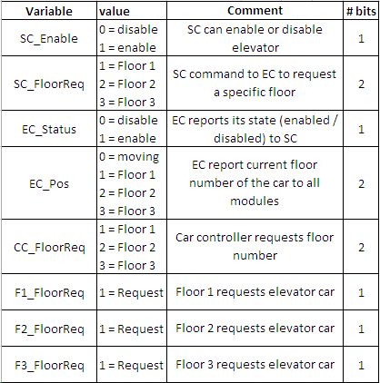

|  |  |  |
| --- | --- | --- |
| **Legend** |  |  |
| SC | *Supervisory Controller* | |
| EC | *Elevator Controller* | |
| CC | *Car Controller* | |
| F1 | *Floor 1 Controller* | |
| F2 | *Floor 2 Controller* | |
| F3 | *Floor 3 Controller* | |



Note: Values in blue are transmitted over CAN network